Project Report
on
“Cancer detection using AI”
Submitted by
Aryan Jadhav
Soham Bhosage
Ganraj Kendre
Varnan Dhondge

Under the guidance of
Prof. P. S. Patil

In partial fulfilment ofj7h
Diploma in Computer Engineering
[2022-2023]
At



DEPARTMENT OF COMPUTER ENGINEERING
MIT POLYTECHNIC
PUNE-411038

Affiliated to

MSBTE

ACKNOWLEDGEMENT

I am profoundly grateful to Prof. P. S. Patil of Computer Engineering Department for her expert guidance and continuous encouragement throughout to see that this project rights its target since its commencement to its completion. I would like to express my deepest appreciation towards Dr. Prof. R. S. Kale Principal, Prof. J. P. Khurpade HOD of Computer Department MAEER’S MIT POLYTECHNIC, Pune, whose invaluable guidance supported me in completing this project.
At last, I must express my sincere heartfelt gratitude to all the staff members of Computer Engineering Department who helped me directly or indirectly during this course of work.

NAME OF STUDENTS
Mr. Aryan Jadhav
Mr. Soham Bhosage
Mr. Ganraj Kendre
Mr. Varnan Dhondge
DIPLOMA IN COMPUTER ENGINEERING

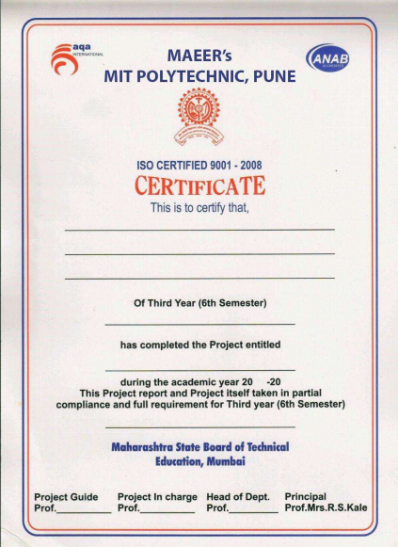

ABSTRACT

Radiology is a broad subject that needs more knowledge and understanding of medical science to identify tumors accurately. The need for a tumor detection program, thus, overcomes the lack of qualified radiologists. Using magnetic resonance imaging, biomedical image processing makes it easier to detect and locate brain tumors. In this study, a segmentation and detection method for brain tumors was developed using images from the MRI sequence as an input image to identify the tumor area.

This process is difficult due to the wide variety of tumor tissues in the presence of different patients, and, in most cases, the similarity within normal tissues makes the task difficult. The main goal is to classify the brain in the presence of a brain tumor or a healthy brain.
The proposed system has been researched based on Berkeley’s wavelet transformation (BWT) and deep learning classifier to improve performance and simplify the process of medical image segmentation. Significant features are extracted from each segmented tissue using the gray-level-co-occurrence matrix (GLCM) method, followed by a feature optimization using a genetic algorithm. The innovative final result of the approach implemented was assessed based on accuracy, sensitivity, specificity, coefficient of dice, Jaccard’s coefficient, spatial overlap, AVME, and FoM.

TABLE OF CONTENTS

 | CONTENTS | PAGE NO.
1 | INTRODUCTION OF PROJECT
 | 1.1 Motivation
 | 1.2 Background
 | 1.3 Need of The Project
2 | LITERATURE SURVEY
3 | SCOPE OF PROJECT
 | - Project objectives
 | 3.2 Project Features
 | 3.3 Project Cost (Overall Cost)
4 | PROPOSED METHODOLOGY
 | 4.1 System Architecture
 | 4.2 Detailed Description of Modules
5 | DETAILS DESIGN AND WORKING PROCESSES
 | 5.1 Hardware Software Requirements,
 | 5.2 DFD’s (0,1) level
 | 5.3 Use Case Diagrams
 | 5.4 Activity diagram
 | 5.5 Sequence Diagram
 | 5.6 Timeline Chart
 | 5.7 Implementation
5.7.1 Sample Code
5.7.2 Types of Testing
5.7.3 Test case
6 | RESULTS AND APPLICATION
 | 6.1 Screen Shot
 | 6.2 Results
 | 6.3 Application
7 | Conclusion and Future Scope
 | References and Bibliography
 | Certificates

LIST OF TABLES

TABLE NO. | TITLE | PAGE NO
Table No. 1 | Cost Table

LIST OF FIGURES

FIGURE NO. | TITLE | PAGE NO
Fig 4.1.1 | System Architecture
Fig 4.1.2 | Fingerprint Sensor
Fig 4.1.3 | Sensor’s connection to Raspberry Pi
Fig 4.1.4 | Entire hardware setup
Fig 5.2.1 | DFD Level 0
Fig 5.2.2 | DFD Level 1
Fig 5.3 | Use-case Diagram
Fig 5.4.1 | Activity diagram for student registration
Fig 5.4.2 | Activity diagram for attendance marking
Fig 5.5 | Sequence diagram
Fig 5.6 | Timeline chart

